**GRADE: A-minus**

**Finding Full Moon Effects on Mental Health Admissions**

**Abstract**

Using data from a study that sought to find whether there were full moon effects on the admission numbers of the emergency room in a mental health hospital, this study sought to determine specifically what the effects were. Two-Way ANOVA tests found an effect for season but not for full moon, F(3, 30) = 5.25, p-value = 0.0049.

**Background/Purpose**

Sheldon Blackman and Don Catalina conducted a study in which they tested for any Full Moon effects on the number of admissions to the emergency room in a mental health hospital. They collected data on the number of admissions by month for one year from August 1971 to July 1972. This study uses the data on whether the admission took place before, after, or during the full moon as well as month of admittance. The purpose of this study was to see if there was an effect of period of admission, whether before, during, or after the full moon, on admissions to the mental health center of the North Richmond Hospital.

**Descriptive Statistics**

This study initially used three variables. Admission was the quantitative dependent variable that represented the number of admissions to the emergency room. The two categorical explanatory variables were Month, which was the month of admission, and Moon, which was whether the admission took place during the full moon, before the full moon, or after the full moon. There were three observations per month for each of the three levels of the Moon variable. This gave us a total of 36 observations. A new variable was then introduced to group together the months of admission by season. Table 1 shows the seasons the months were grouped into.

*Table 1*

|  |  |  |  |
| --- | --- | --- | --- |
| Winter | Spring | Summer | Fall |
| Dec Jan Feb | Mar Apr May | Jun Jul Aug | Sept Oct Nov |

*Figure 1*

Descriptive Statistics of the variables for Admissions, Moon, and Month

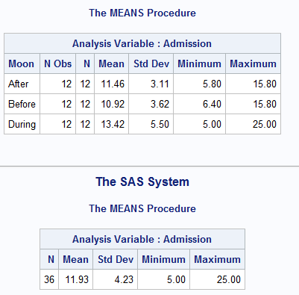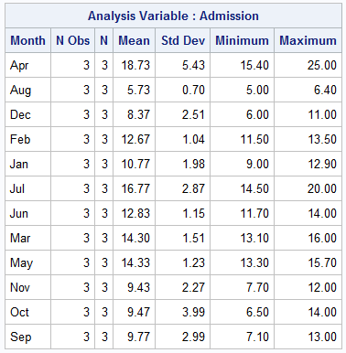

Figure 1 shows the overall mean number of admissions, on the bottom left, the means grouped by date of whether it was before, after, or during a full moon, on the top left, as well as the means of admission by month on the right. Overall mean for the 36 observations was 11.93 with the highest value being 25.00 and the lowest value being 5.00. The period of during the full moon has the biggest variance from the three groups.

*Figure 2*

Admissions of the individual observations

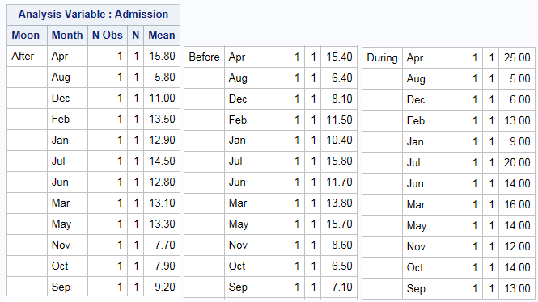

During the period before the full moon, the highest mean was 15.80 during July with the lowest mean of 6.40 during August. During the period after the full moon, the highest mean was 15.80 during April while the lowest mean was 5.80 in August. For all three periods, August seems to have had the lowest number of admissions. At first glance it appears the first half of the year has the higher means as compared to the second half of the year especially for the periods before and after the full moon.

*Figure 3*

Means of Admission by the variable Season

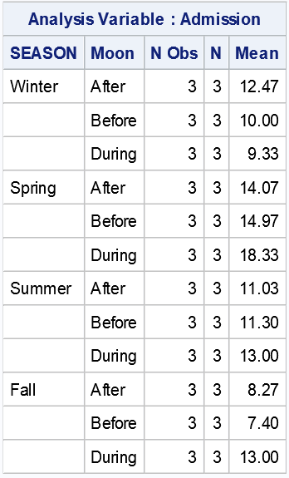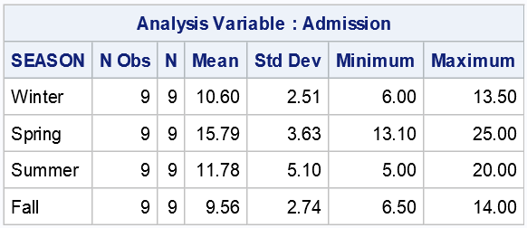

After grouping together the months by season, shown in Figure 3, we can see that the season with the highest means was Spring, M = 15.79 without taking into variable Moon, and M = 18.33, during the full moon.

**Methods and Results**

Initially a Two-Way ANOVA test was run to compare the main effects of the variable Moon, which denoted whether the period of admission was before, after, or during a full moon, and the variable month, which indicated the month of admission, and the interaction of period and month on the number of admissions. However, results showed no F-values or p-values as the number of observations were the same number as the number of total degrees of freedom. Therefore, it was determined that recoding the Month variable into Seasons would present us with a better look at the data.

*Figure 4*

ANOVA Table with interaction

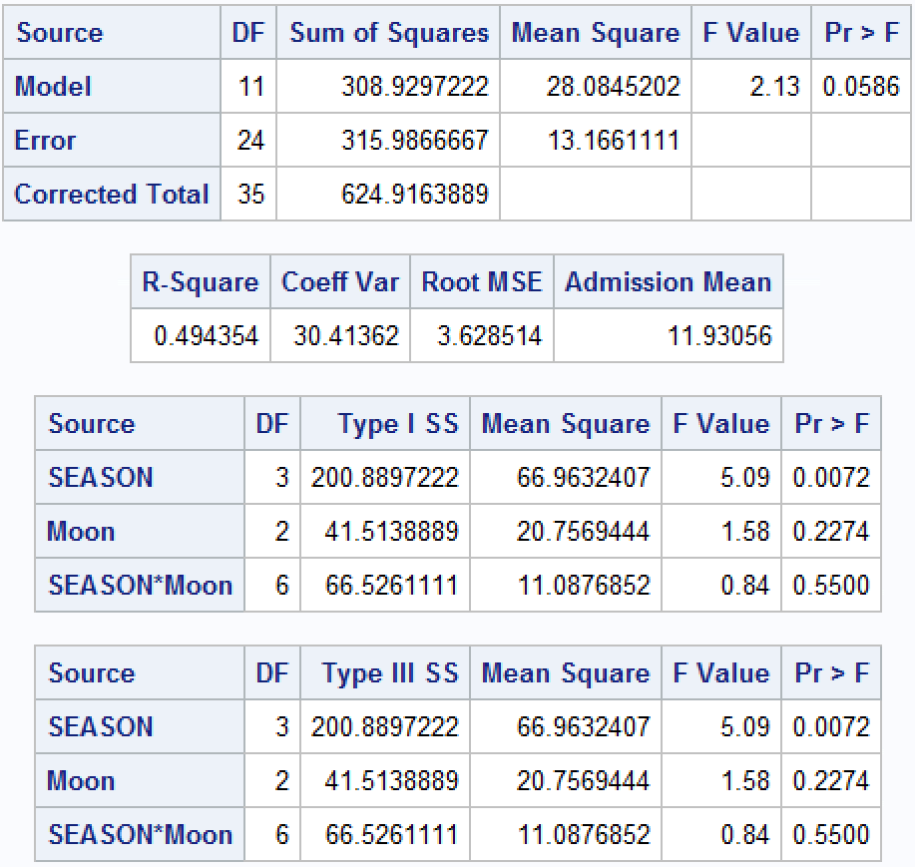

Another factorial Two-Way F-test was conducted to first determine if there is an interaction between Season and Moon with the null hypothesis of H0: No Interaction between Moon and Season. Next, we tested for the main effects of Season and Moon on the Admission of patients by way of the null hypotheses H0: The mean number of admissions are similar for each season while controlling for the state of the Moon and H0: The mean number of admissions are similar among the states of the Moon while controlling for the season.

Figure 4 shows the results of the initial hypothesis test H0: No interaction between Season and Moon variables. Interaction between the variable Moon and Season was not statistically significant with a p-value = 0.55. Thus, we fail to reject the hypothesis that there is no interaction present. We then remove the interaction term and reconstruct the ANOVA table.

Another ANOVA F-test without the interaction term was conducted to test the hypothesis H0: The mean admissions rates are similar for each season, while controlling for the Moon variable. With an F-value of 5.25 and a P-value of 0.004, we reject the null hypothesis and conclude that there exists strong evidence supporting that there is a difference amongst the means of Admissions per Season.

From Figure 5, we can also analyze the main effect of the state of the Moon on the mean number of admissions by testing the null hypothesis H0: The mean number of admissions are similar among the states of the Moon while controlling for the season.

We see that the F-value is 1.63 with a P-value of 0.21. We fail to reject the null hypothesis and conclude that for each level of the state of the Moon, the mean numbers of admissions while controlling for the Season, are similar.

.

*Figure 5*

SAS Output for the two-way ANOVA test without interaction

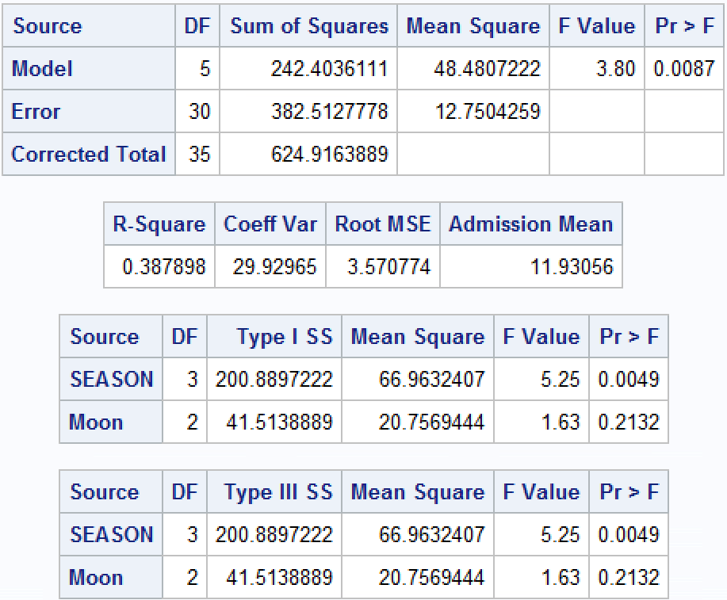

Post-hoc Tukey results showed that Spring (M = 15.79, SD = 3.63) and Summer (M = 11.78, SD = 5.10) had statistically significant higher means than Winter (M = 10.60, SD = 2.51) and Fall (M = 9.56, SD = 2.74). However, there was no significant difference between Spring and Summer.

*Figure 6*

Tukey test SAS output

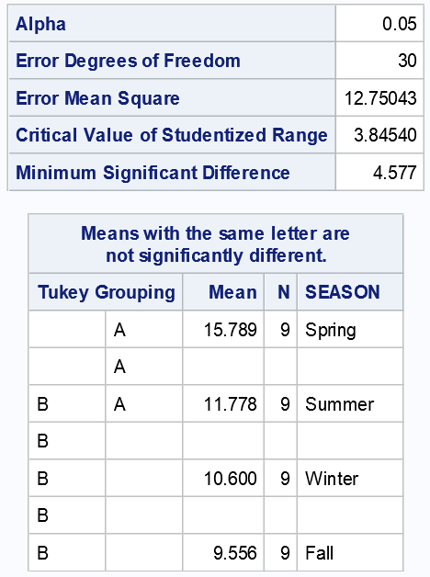

**Conclusions**

To test whether or not there is a Full Moon effect on people’s mental health, we conducted an ANOVA F-test, where we wished to examine the effects of the Season and the state of the Moon on the mean number of admissions of patients to the Emergency Room of a mental institution. Before doing so, we first tested to ensure that there was not sufficient enough evidence to determine that the interaction between Season and the state of the Moon was sufficient. We then tested the main effects of the Season and state of the Moon on the number of patients admitted, while controlling for the other variable.

The original study mentioned that they found significantly higher means of admission during the days of the full moon and after as compared to the days before the full moon. This study couldn’t replicate findings as the F-test would not give F-values or p-values with the dfs matching total number of observations. What this study found, however, was that there is a significant difference in the means of admissions when looking at the data grouped by seasons. Post-hoc Tukey’s test found that there was no difference among the means between Spring and Summer but these seasons were higher than both Fall and Winter. Future tests might want to test additional variables that relate to the seasons to see if there’s a stronger connection to be found.

**Limitations**

Given that the original paper only sought to find whether there was a higher number of admissions during the full moon as opposed to before or after the full moon, the dataset was small with 36 observations. Another of the limitations of the dataset was lack of a reason for admittance to the emergency room’s mental health center. Full moons tend to occur towards the end of a month. Therefore, there could be a reason why towards the end of the month more people are being admitted to the emergency room. For example, perhaps not having rent ready for next month and visiting the emergency room with suicidal thoughts could be one reason. Another limitation was that we only had information for one hospital. If we had information for more hospitals as well as region, one could also run analyses on whether there actually is an effect of full moon by which region seems to be more superstitious. That kind of study can connect political views or religions to the level of superstition and from there see if there’s any effect.

**References**

Blackman, S., & Catalina, D. (October 06, 2016). The Moon and the Emergency Room. *Perceptual and Motor Skills, 37,* 2, 624-626.

**Appendix**

**data** MentalHealth;

set MentalHealth;

Season = '.';

if Month = 'Jan' or Month = 'Feb' or Month = 'Dec' then Season = **1**;

if Month = 'Mar' or Month = 'Apr' or Month = 'May' then Season = **2**;

if Month = 'Jun' or Month = 'Jul' or Month = 'Aug' then Season = **3**;

if Month = 'Sep' or Month = 'Oct' or Month = 'Nov' then Season = **4**;

**run**;

**proc** **means** n mean std data=MentalHealth;

class Month Moon;

var Admission;

**run**;

**proc** **means** n mean std data=MentalHealth;

class Month;

var Admission;

**run**;

**proc** **means** n mean std data=MentalHealth;

class Moon;

var Admission;

**run**;

**proc** **means** n mean std data=MentalHealth;

class Season;

var Admission;

**run**;

**proc** **means** n mean std data=MentalHealth;

class Season Moon;

var Admission;

**run**;

**proc** **glm** data=MentalHealth;

class Season Moon;

model Admission = Season Moon Season*Moon;

**run**;

**proc** **glm** data=MentalHealth;

class Season Moon;

model Admission = Season Moon;

means Season / tukey;

**run**;